**Experiment-6**

**Student Name: Saksham Kumar UID: 22BET10333**

**Branch: BE-IT**  **Section/Group: 22BET_IOT-703/**B

**Semester:** **6th Subject Code: 22ITP-351**

**Problem 1**

**Aim:** Maximum Depth of Binary Tree **Code:**  class Solution { public: int

maxDepth(TreeNode* root) {

if (!root) {

return 0;

}

return 1 + max(maxDepth(root->left), maxDepth(root->right));

}

};

**Output:**

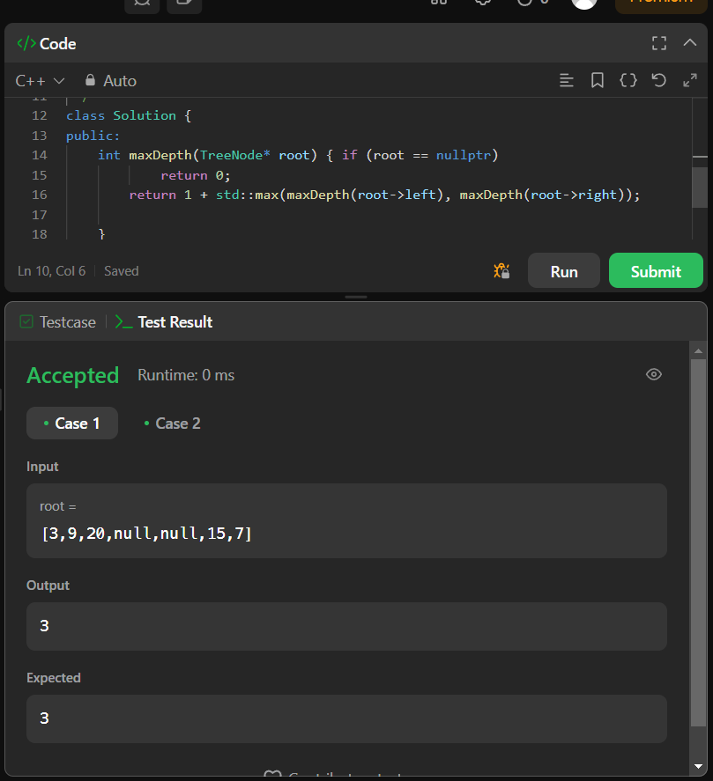 Case 1 Case 2

**Problem 2**

**Aim:**

Validate Binary Search Tree

**Code:**  class Solution { public: bool isValidBST(TreeNode* root) { return valid(root, LONG_MIN, LONG_MAX);

}

private: bool valid(TreeNode* node, long minimum, long maximum) {

if (!node) return true;

if (!(node->val > minimum && node->val < maximum)) return false;

return valid(node->left, minimum, node->val) && valid(node->right, node->val, maximum);

} };

bool isMirror(TreeNode* n1, TreeNode* n2) { if (n1 == nullptr && n2 == nullptr) {

return true;

}

if (n1 == nullptr || n2 == nullptr) {

return false;

}

**Output:**

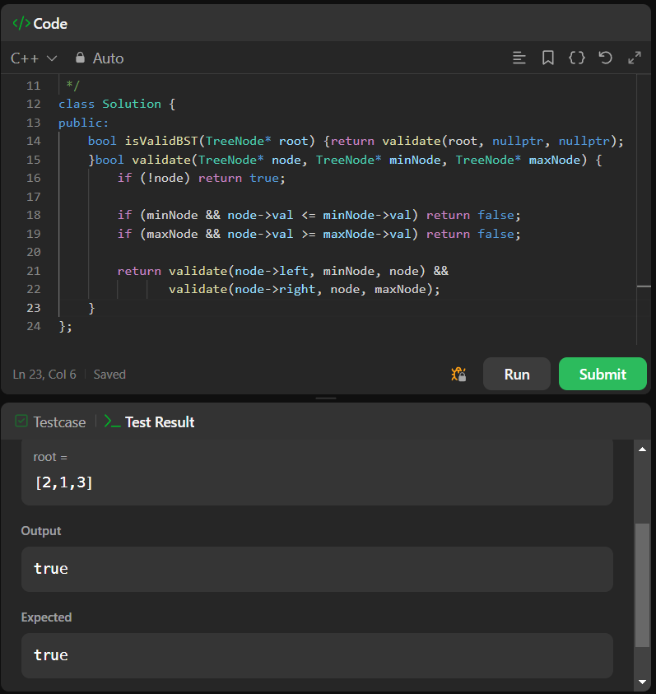

Test Case 1

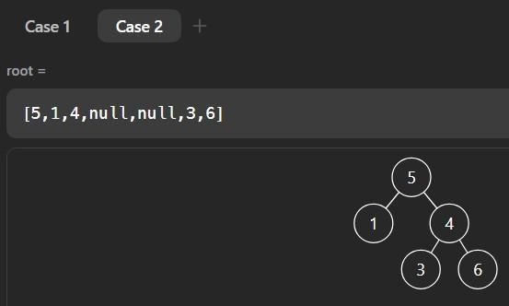 Test Case 2

Symmetric Tree **Code:**

class Solution { public: bool

isSymmetric(TreeNode* root) { return isMirror(root->left, root->right);

}

private:

bool isMirror(TreeNode* n1, TreeNode* n2) { if (n1 == nullptr && n2 == nullptr) {

return true;

}

if (n1 == nullptr || n2 == nullptr) {

return false;

}

return n1->val == n2->val && isMirror(n1->left, n2->right) && isMirror(n1->right, n2->left);

} };

**Output:**

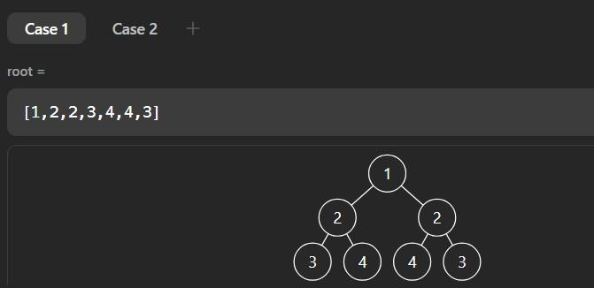 Case 1

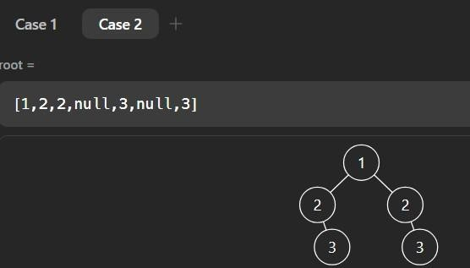

Case 2

**Problem 4** **Aim:**

Binary Tree Level Order Traversal **Code:**  class Solution { public: vector<vector<int>>

levelOrder(TreeNode* root) {

vector<vector<int>>ans;

if(root==NULL)return ans;

queue<TreeNode*>q; q.push(root); while(!q.empty()){ int s=q.size(); vector<int>v; for(int i=0;i<s;i++){

TreeNode *node=q.front(); q.pop();

if(node->left!=NULL)q.push(node->left); if(node>right!=NULL)q.push(node->right); v.push_back(node->val);

}

ans.push_back(v);

}

return ans;

} };

**Output:**

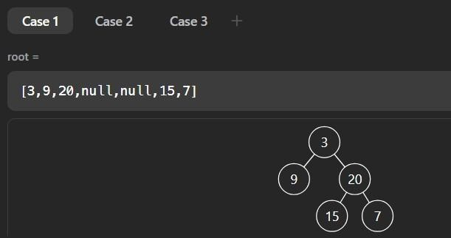

Case 1



Case 2

Convert Sorted Array to Binary Search Tree **Code:**

#include <vector>

using namespace std;

class Solution { public:

TreeNode* sortedArrayToBST(vector<int>& nums) { return helper(nums, 0, nums.size() - 1);

}

private:

TreeNode* helper(vector<int>& nums, int left, int right) { if (left > right) return nullptr;

int mid = left + (right - left) / 2;

TreeNode* root = new TreeNode(nums[mid]); root->left = helper(nums, left, mid - 1); root>right = helper(nums, mid + 1, right); return root;

}

};

**Output:**

Case 1 Case 2

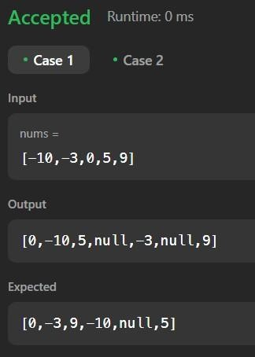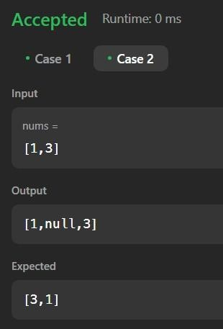

Binary Tree Inorder Traversal **Code:**  class Solution { public: void inorder(TreeNode* root, vector<int>& ans) { if (!root) return; inorder(root->left, ans); ans.push_back(root-

>val); inorder(root->right, ans); }

vector<int> inorderTraversal(TreeNode* root) {

vector<int> ans; inorder(root, ans); return ans;

}

};

**Output:**

Case 1 Case 2

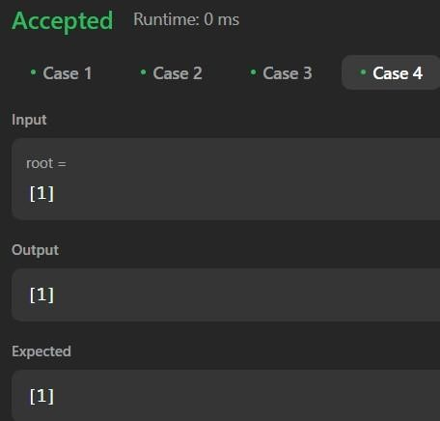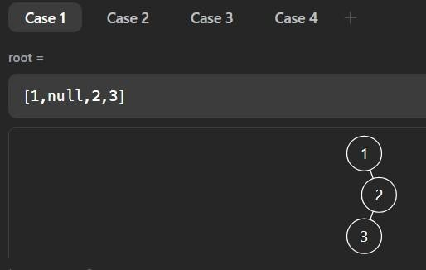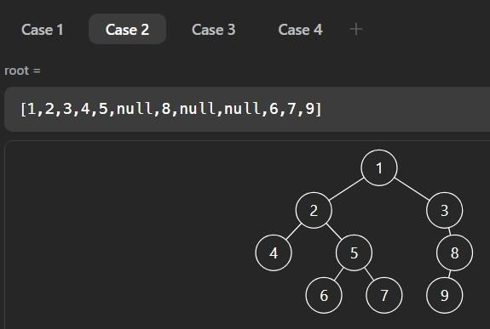

Case 3

Binary Zigzag Level Order Traversal **Code:**  class Solution { public:

vector<vector<int>> zigzagLevelOrder(TreeNode* root) {

if (!root) return {}; vector<vector<int>> result; queue<TreeNode*> q; q.push(root);

bool leftToRight = true;

while (!q.empty()) { int levelSize =

q.size(); vector<int> level(levelSize); for (int i = 0; i < levelSize; ++i) { TreeNode* node = q.front(); q.pop(); int index

= leftToRight ? i : (levelSize - 1 - i); level[index] = node->val;

if (node->left) q.push(node->left);

if (node->right) q.push(node->right);

}

leftToRight = !leftToRight;

result.push_back(level);

}

return result;

} };

**Output:**

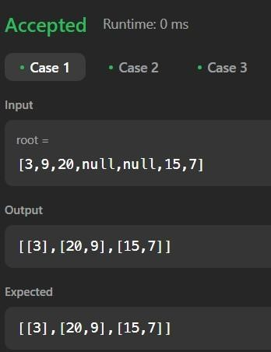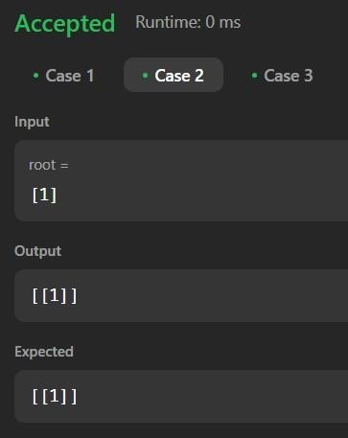

Case 1 Case 2

**Problem 8** **Aim:**

Construct Binary Tree from Inorder and Postorder Traversal **Code:**

class Solution { public:

TreeNode* buildTree(vector<int>& inorder,int instart,int inend, vector<int>& postorder,int poststart,int postend,map<int,int>& inMap){

if(instart>inend || poststart>postend){ return NULL;

}

TreeNode* root=new TreeNode(postorder[postend]); int inRoot=inMap[root->val]; int numsLeft=inRoot-instart; root-

>left=buildTree(inorder,instart,inRoot-1,postorder,poststart,poststart+numsLeft-1,inMap); root>right=buildTree(inorder,inRoot+1,inend,postorder,poststart+numsLeft,postend-1,inMap); return root; }

TreeNode* buildTree(vector<int>& inorder, vector<int>& postorder) { map<int,int> inMap;

for(int i=0;i<inorder.size();i++){

inMap[inorder[i]]=i;

}

TreeNode* root=buildTree(inorder,0,inorder.size()-1,postorder,0,postorder.size()-1,inMap); return root;

}

};

**Output:**

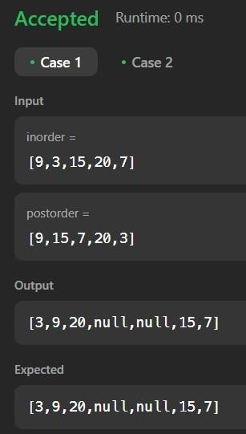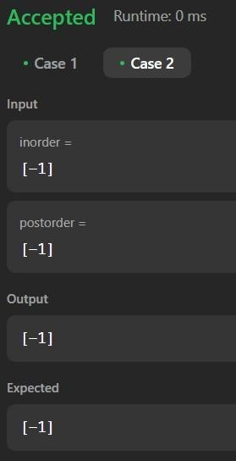

Case 1 Case 2

Kth Smallest element in a BST **Code:**  class Solution { public: void inOrderTraversal(TreeNode* root, vector<int> &v){

if(root == NULL) return;

//left, root, right

inOrderTraversal(root->left, v); v.push_back(root-

>val); inOrderTraversal(root->right, v);

}

int kthSmallest(TreeNode* root, int k) { vector<int> v;

inOrderTraversal(root, v);

return v[k-1];

} };

**Output:**

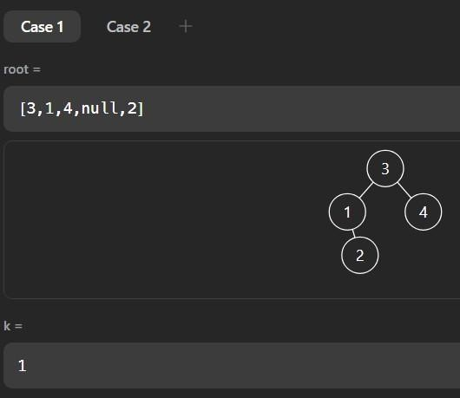

Case 1

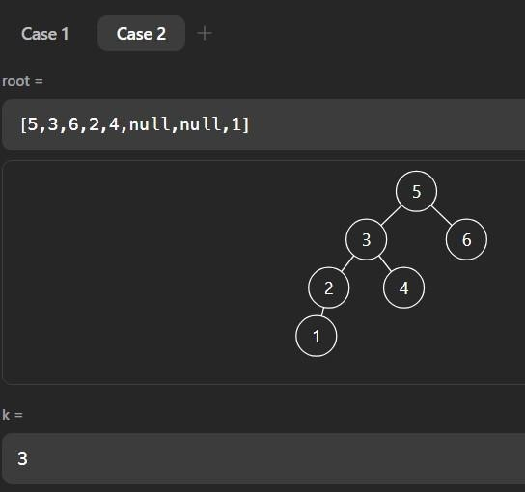

Case 2

**Problem 10** **Aim:**

Populating Next Right Pointers in Each Node **Code:**  class Solution { public:

**Aim:**

Node* connect(Node* root) { if(root==nullptr) return {};

queue<Node*> q; q.push(root);

while(!q.empty()){

int n = q.size();

for(int i=0;i<n;i++){ Node* t = q.front(); q.pop();

if(i!=n-1){

t->next=q.front();

}

if(t->left) q.push(t->left);

if(t->right) q.push(t->right);

}

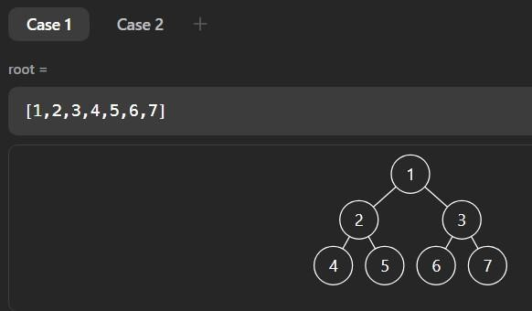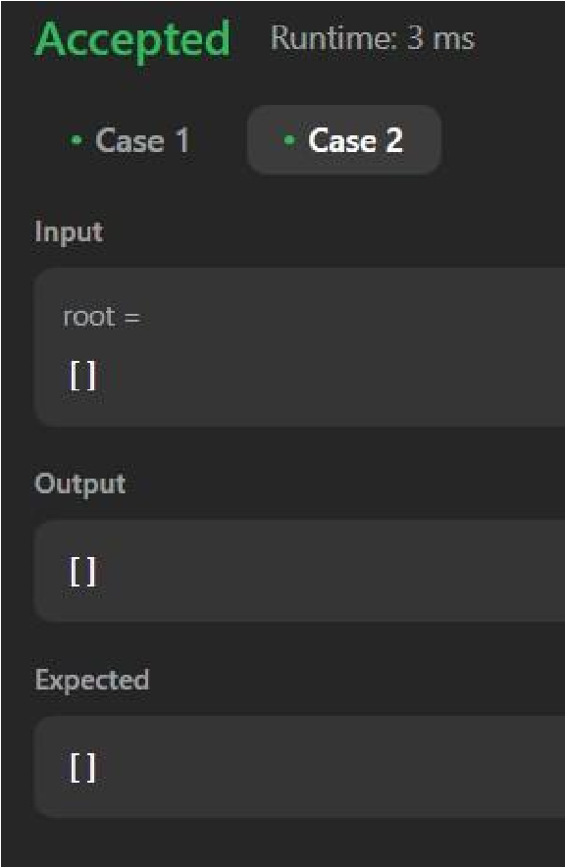

} return root;

} };

